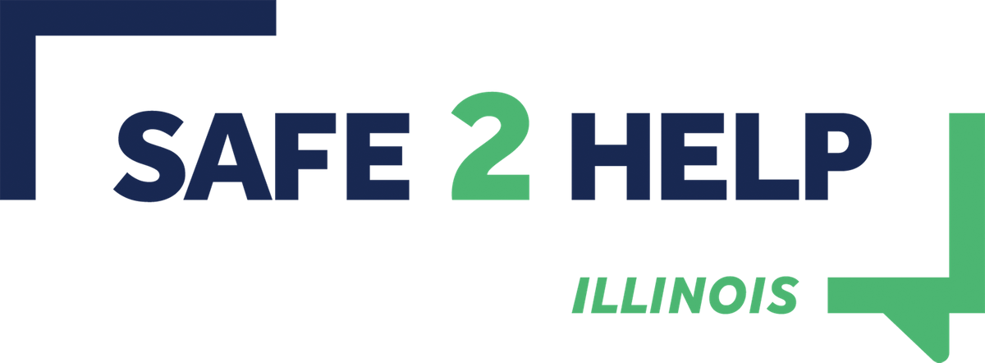
www.Safe2HelpIL.com

Safe2Help Illinois Overview for Law Enforcement/Public Safety Answering Points

In December 2020, the State of Illinois launched a school safety program called Safe2Help Illinois in an effort to raise awareness of 21st century threats facing schoolchildren in Illinois. The purpose of this summary and associated standard operating procedure is to provide law enforcement with information about the Safe2Help Illinois so public safety agencies understand the program’s mission and take appropriate action if a student safety report received impacts a school district your jurisdiction serves.

Background:
According to the Federal Bureau of Investigations, approximately 90-percent of mass shootings that occurred, someone knew something before the event took place. These signs range from social media posting to observed signs of distress. Within the last 15 years, in almost every case of a mass school shooting committed by a student in the United States, after action reports indicate at least one other student knew something might happen and did not come forward for a variety of reasons.

Mission:
In the absence of a trusted adult, Safe2Help Illinois will offer students a safe, confidential way in which to share information that might help prevent suicides, bullying, school violence or other threats to school safety. This program is not intended to suspend, expel or punish students. Rather, the goal is to get students to “Seek Help Before Harm.” Safe2Help Illinois will also develop an educational curriculum aimed at changing the culture in Illinois schools while also providing the resources to help parents and educators reinforce the components of this program.

About Safe2Help:
Safe2Help Illinois is a 24/7 program where students can use a free app, text/phone, website (Safe2HelpIllinois.com) and other social media platforms to report school safety issues in a confidential environment. Once vetted, the tips will immediately be shared with local school officials, mental health professionals and/or local law enforcement, depending on the nature of the tip. The program also will help local officials by connecting them with mental health resources or other appropriate resources to intervene and help students before they harm themselves or others.

Changing the Culture:
Safe2Help is a long-term initiative to change the school culture in Illinois. By providing a recommended educational curriculum as early as preschool, we hope to remove the stigma associated with mental health issues, foster a culture of kindness, and instill important lessons such as the difference between telling and tattling, internet safety, and suicide prevention.

For more information about Safe2Help Illinois, please visit our program website at www.Safe2HelpIL.com or email INFO@Safe2HelpIL.com.

