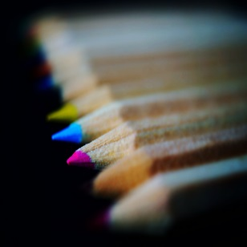

The Darien Woman’s Club will be sponsoring “In Person” the Annual Creative Youth Art Fair February 25-27, 2022 at Cass Junior High in Darien. This event is open to students from Pre-K through High School. It is hoped that students from your school will participate in this, our Club’s 40th annual event. On Sunday, February 27, 2022, the Art Fair is open to the public for viewing From 2:00 to 3:30 with an awards ceremony at 3:15. Artwork must be dropped off at Cass Junior High on Friday with judging of the artwork taking place on Saturday. Detailed information regarding artwork submissions can be found on the registration form. Registration can be done electronically at Eventbrite: or on hard copy postmarked no later than February 11th, 2022.
An Exhibit of the Divisional winners and representative artwork will be displayed at The Indian Prairie Public Library throughout the month of March. The DWC Creative Youth Art Fair Exhibit celebrates National Youth Art Month in March and shares the impact of art education with the community.
To view prior exhibits please go to www. darienwomansclub.org and click on the link for Creative Youth Art Fair. It is a fun and educational event that is enjoyed by the entire community.
Links:
https://www.darienwomansclub.org/what-we-do/youth-art-fair
https://www.darienwomansclub.org/upcoming-events/creative-youth-art-fair
https://dwc2022creativeyouthartfair.eventbrite.com/

This is not a school district sponsored event.

For further assistance please contact:
Mary Beardsley, member of the Darien Woman’s Club Creative Youth Fair Committee, mpbeardsley@yahoo.com, or you can use the Darien Woman’s Club email, info@darienwomansclub.org. We are looking forward to viewing your art work at the DWC Creative Youth Art Fair.

