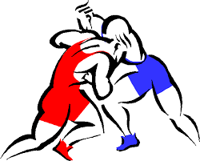
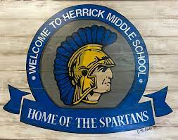

Herrick Middle School Wrestling Intramurals

When: November 29 and 30
December 1, 6, 7, 8, 13, 14, and 15

Time: 3:20 pm - 4:20 pm

Where: Small gym

Topics Covered: Health, Nutrition, Conditioning, Strength Building, Balance, Hand Eye Coordination, Social Development, Character Building

If you are interested in Wrestling Intramurals, see Mr. Vidovic in Room 100 or send an email: jvidovic@dg58.org

