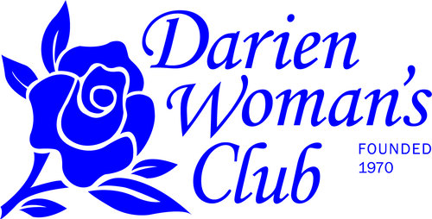

The Darien Woman’s Club will be sponsoring “In Person” the Annual Creative Youth Art Fair February 24-26, 2023 at Cass Junior High in Darien. This event is open to students from Pre-K through High School. It is hoped that students from your school will participate in this, our Club’s 41st annual event. On Sunday, February 26, 2023, the Art Fair is open to the public for viewing from 2:00 to 3:30 with an awards ceremony at 3:15. Artwork must be dropped off at Cass Junior High on Friday with judging of the artwork taking place on Saturday.

An Exhibit of the Divisional winners and representative artwork will be displayed at the Indian Prairie Public Library throughout the month of March. The DWC Creative Youth Art Fair Exhibit celebrates National Youth Art Month in March and shares the impact of art education with the community.

Please let me know if you would like your school to participate in this wonderful event.

Sincerely,

Jean Szwaya
Art Fair Chairman, 2023
szwayaj@gmail.com

