2022 DOWNERS GROVE SOUTH WRESTLING SUMMER CAMPS
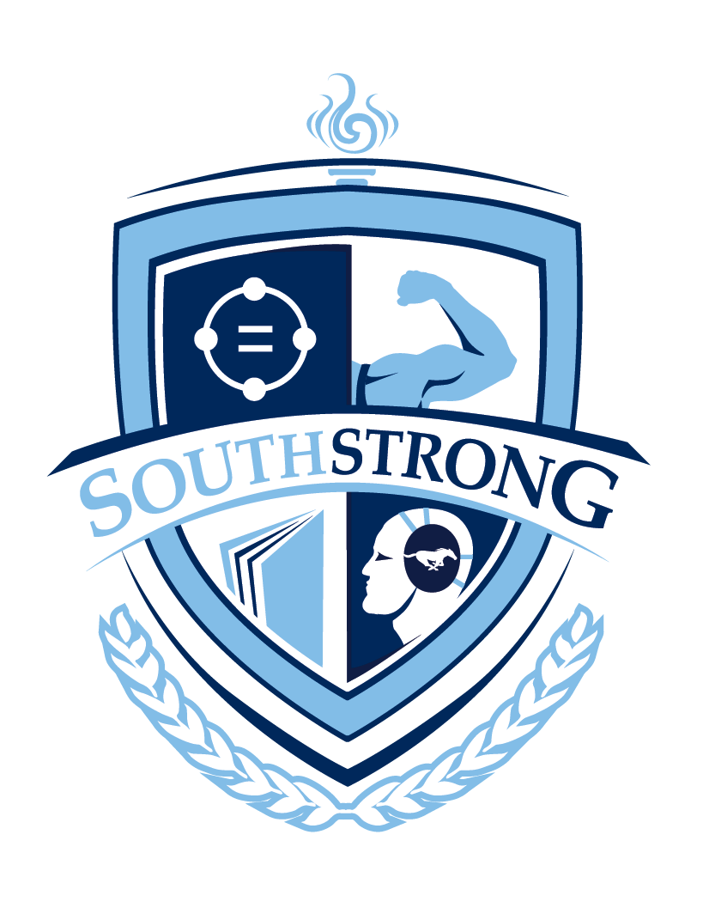
The Downers Grove South Wrestling Summer Camps will be offered in two sessions. All grades are what the student will be entering during the 2022-2023 school year.

GRADES 1-6
Monday, June 20th through Thursday June 23rd
4:00 PM- 5:30 PM in the DGS Wrestling Room
Cost: $80 (includes dgs wrestling shirt)
For all experience levels from beginner to wrestlers with experience

GRADES 7-12
Camp practices will be held on the following dates:
Tuesday, June 7, Thursday, June 9
Tuesday June 14, Thursday, June 16
Tuesday June 21, Thursday, June 23
6:00 pm – 7:30 pm in the DGS wrestling room

Cost: $80 (includes dgs wrestling shirt)
BOTH CAMPS INCLUDE DGS SOUTHSTRONG SHIRT
No wrestler will be turned away because of money! Please contact coach sean lovelace with any questions in regards to the 2018 DGS SUMMER WRESTLING CAMPS.

REGISTER ON THE DGS ATHLETICS WEBSITE:
http://il.8to18.com/dgs - CLICK ON SUMMER CAMP REGISTRATION NOW OPEN IN THE D99 WEB STORE
Sean Lovelace- slovelace@csd99.org

check out all things dgs wrestling at this site:
http://dgswrestling.blogspot.com/

Follow DGS Wrestling on Twitter:
@DGS_WRESTLING

Follow DGS Wrestling on Instagram:
dgsouthstrong

