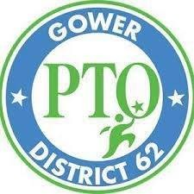 | Monday, November 9, 2020  4:00 pm – 5:00 pm  Gower West Elementary School,  Gower District 62  7650 Clarendon Hills Rd,  Willowbrook, IL 60527 | 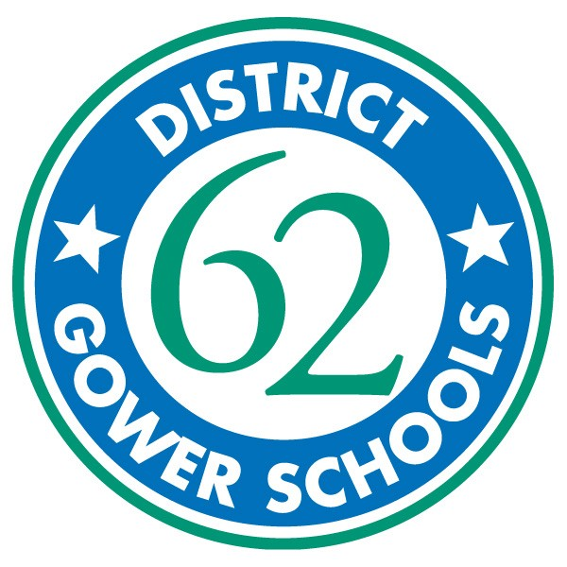

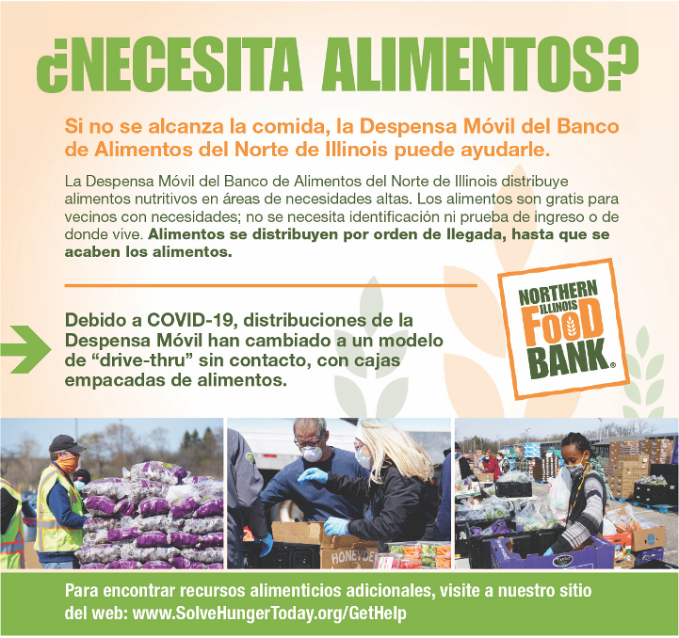

Lunes, 9 de noviembre de 2020
4:00 pm – 5:00 pm

Gower West Elementary School,
Gower District 62

7650 Clarendon Hills Rd,
Willowbrook, IL 60527

