Hi Todd,

The Village's zoning map is available on-line at this location: https://vdg.maps.arcgis.com/apps/webappviewer/index.html?id=b9d333082e8c49d999b4d77d22e34ef7

Below is a screen shot from the on-line map.

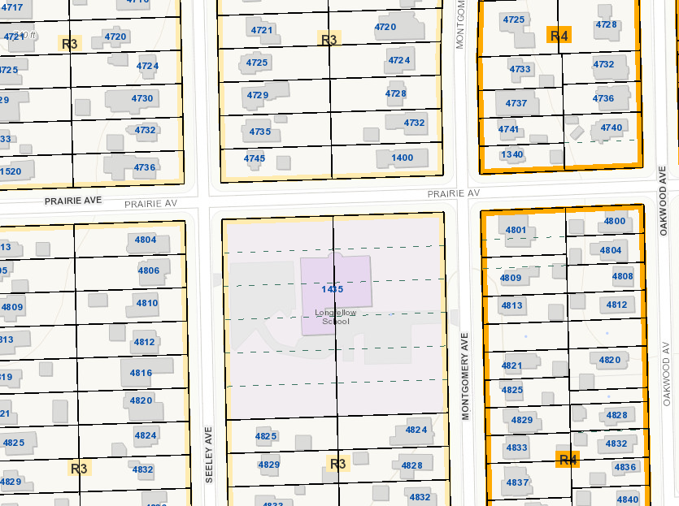

The R-3 setbacks can be found on-line here: https://downersgrove.municipalcodeonline.com/book?type=ordinances#name=Article_28.II_Residential_Districts and here: https://downersgrove.municipalcodeonline.com/book?type=ordinances#name=Article_28.XIV_Measurements

The street setbacks are 30 ft from either Seeley or Montgomery. The setback from Prairie would be 24 feet. On a corner lot, the applicable street setback requirements may be reduced along one street frontage if necessary to allow a building width of 30 ft. The calculation is as follows:

60 ft wide lot minus 6 ft south setback minus 30 ft buildable width equals 24 ft setback from Prairie Ave.

Please let me know if you have any other questions.
Stan.

