5111 Chase Ave., Downers Grove, IL 60515 Phone: 630.971.0565 Fax: 630.971.9594
Cleaning Supplies
- Buckets
- Sponges
- Multi-purpose Cleaner
- Paper Towels
- Liquid Dish Soap
- Toilet Bowl Cleaner
- Toilet Bowl Brush
- Cleaning Cloths
- Multi-purpose Wipes
- Laundry Soap
- Dust Spray
- Glass Cleaner
Personal Care Items
- Bar Soap
- Shampoo/Conditioner
- Toothbrush/Toothpaste
- Deodorant
- Shaving Cream/Razor
- Toilet Paper

When available, Sharing Connections gives every family a bucket of cleaning supplies. Unfortunately, the funding that our clients depend on for food does not cover cleaning supplies. We rely on groups to help us by having cleaning supply drives. Thank you for supporting Sharing Connections!
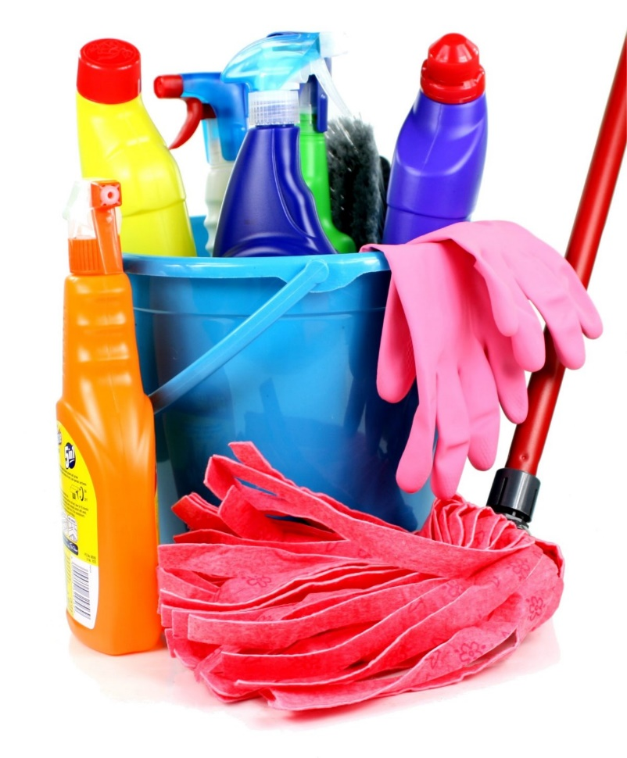
TOGETHER, We Furnish Hope!

For more information please visit: www.sharingconnections.org/donate-items.html

